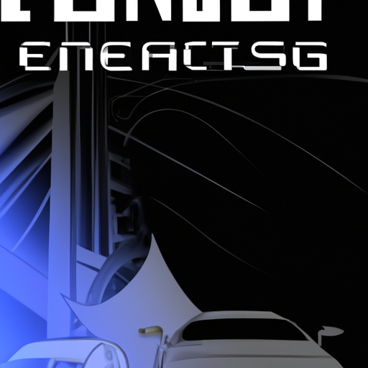

fast and furious

# Table of Contents

Title: Fast and Furious

Chapter 2: Fast and Furious

Title: Fast and Furious - They Unite

Title: Fast and Furious

# Title: Fast and Furious

Description: its the meet up of heroes

Chapter 1: The Meet-Up of Heroes  
  
In a world where technology and magic intertwined, a group of unlikely heroes gathered at the annual Engineering Expo – an event that brought together the brightest minds and the most daring adventurers. Among them were Aurora, a skilled engineer with a passion for building flying machines, Kael, a mystical wizard who could wield the power of the elements, and Thorne, a daring rogue known for his speed and agility.  
  
As the Expo kicked off with a grand parade showcasing the latest inventions and enchantments, Aurora, Kael, and Thorne found themselves drawn to a mysterious booth at the far end of the exhibition hall. The booth was shrouded in secrecy, with a sign that simply read: "Fast and Furious – Dare to Challenge?"  
  
Intrigued, the trio approached the booth, where a hooded figure awaited them. "Welcome, heroes," the figure spoke in a voice tinged with magic. "I have a proposition for you. Inside this booth lies a series of engineering challenges unlike any you've faced before. Complete them, and you will unlock the greatest invention this world has ever seen."  
  
Eager for adventure, Aurora, Kael, and Thorne accepted the challenge without hesitation. The first task was to build a vehicle that could traverse a treacherous obstacle course filled with traps and pitfalls. Aurora used her engineering skills to design a sleek and aerodynamic hovercraft, while Kael enchanted the vehicle with wind and fire to boost its speed and agility. Thorne, with his quick reflexes, piloted the craft with precision, dodging obstacles with finesse.  
  
As the hovercraft raced towards the finish line, the crowd gasped in awe at the display of teamwork and innovation. And as the vehicle crossed the finish line in a blaze of glory, a hidden door opened in the booth, revealing a chamber filled with mysterious blueprints and artifacts.  
  
The hooded figure stepped forward, revealing himself to be an ancient inventor thought to be long gone. "You have proven yourselves worthy," he said with a smile. "Now, together, we shall unlock the secrets of the fastest and most powerful invention known to man – the Time-Warp Engine."  
  
With their hearts pounding with excitement, Aurora, Kael, and Thorne braced themselves for the greatest engineering challenge of their lives – to harness the power of time itself.

# Chapter 2: Fast and Furious

Description: they will have a fight

As the sun began to set, casting a warm golden hue over the castle gardens, Princess Elara and Prince Leo stood facing each other, their expressions tense. The once enthusiastic duo now found themselves at odds as conflicting ideas clashed.  
  
Princess Elara, with her keen eye for design and innovation, proposed a grand engineering project to enhance the castle's defenses. She envisioned a series of automated turrets that would bolster the walls and keep their kingdom safe from potential threats. Prince Leo, on the other hand, believed in traditional methods of defense, favoring a skilled army over technological advancements.  
  
Their argument echoed through the courtyard, drawing the attention of curious onlookers. Sparks seemed to fly not only between the two royals but also between their opposing viewpoints. The air crackled with tension as they debated the merits of technology versus tradition, each unwilling to back down.  
  
Princess Elara argued passionately for the turrets, citing their efficiency and ability to cover vast areas of the castle walls simultaneously. She explained how they could be programmed to target incoming threats with precision, minimizing the need for a large army and reducing the risk to their soldiers.  
  
Prince Leo, however, raised concerns about the reliability of such advanced machinery, pointing out that technology could fail at crucial moments. He emphasized the importance of skilled soldiers who could adapt to changing circumstances, relying on their training and experience to defend the kingdom.  
  
The clash of ideas escalated into a full-blown confrontation, with emotions running high. As the sun dipped below the horizon, casting long shadows across the courtyard, Princess Elara and Prince Leo faced a decision: compromise and find a middle ground, or continue to butt heads, risking not only their own relationship but the safety of their kingdom as well.

# Title: Fast and Furious - They Unite

Description: they unite

Description: In this chapter, the main characters finally come together to face the challenges ahead as a unified team.  
  
Chapter 3: Fast and Furious - They Unite  
  
As the sun set on the horizon, casting a warm glow over the rolling hills, the group of engineers gathered around a crackling fire at the edge of the village. Elena, with her eyes sparkling with determination, finally spoke up, breaking the silence that had settled over them.  
  
"We need to work together if we're going to solve these challenges," she stated firmly, her voice steady and resolute. "Each of us brings something unique to the table, and together, we can accomplish anything."  
  
The others nodded in agreement, their faces illuminated by the flickering flames. Carlos, with a twinkle in his eye, added, "We have the skills, the passion, and the drive to overcome any obstacle that comes our way. Let's put our heads together and come up with a plan."  
  
And so, under the canopy of stars, the group began to brainstorm ideas, each sharing their expertise and insights. Mateo suggested using renewable energy sources to power their inventions, while Sofia proposed designing a network of sensors to monitor the village's vital systems in real-time. Alejandro, with his knack for robotics, offered to build drones to assist in reconnaissance missions.  
  
As the night wore on, their plans took shape, evolving into a comprehensive strategy that encompassed all their strengths and resources. They mapped out a timeline, assigned roles and responsibilities, and set clear objectives to guide their progress.  
  
With a newfound sense of unity and purpose, the engineers retired to their makeshift tents, their hearts filled with hope and determination. Tomorrow would mark the beginning of their journey, a journey filled with challenges, triumphs, and the joy of working together towards a common goal.  
  
The stars shone brightly overhead, casting their light on the sleeping village and the group of engineers who, united in their passion for innovation, dreamed of a brighter future for all.

# Title: Fast and Furious

Description: the conquer and save the world

Description: The Conquest to Save the World  
  
Chapter 4: The Race Against Time  
  
As the sun rose over the horizon, illuminating the world in a warm glow, our daring engineers, Jack and Lily, were ready for their next challenge. The fate of the world rested on their shoulders as they geared up for the final leg of their mission. With their advanced technology and unwavering determination, they were prepared to face whatever obstacles lay ahead.  
  
Jack and Lily climbed into their state-of-the-art vehicle, the Quantum Accelerator, a marvel of engineering that could travel at unimaginable speeds. The countdown began as they revved up the engine, the hum of power vibrating through the air.  
  
Their destination was the heart of an active volcano, where a rogue scientist had unleashed a powerful device capable of causing catastrophic natural disasters around the globe. Racing against time, they navigated treacherous terrain and dodged molten lava streams, pushing the limits of their vehicle to the max.  
  
As they neared the volcano's crater, they spotted the scientist's lair, a menacing structure perched precariously on the edge. Without hesitation, Jack activated the Quantum Accelerator's turbo boost, propelling them towards their target with incredible speed.  
  
With a final burst of energy, they crashed through the doors of the lair, facing the scientist in a dramatic showdown. Using their engineering skills and quick thinking, Jack and Lily disabled the device just moments before it could unleash its destructive power.  
  
As the volcano rumbled in protest, threatening to erupt, our heroes raced back to safety, their mission accomplished. The world was saved once again, thanks to their bravery and ingenuity in the face of danger.  
  
Exhausted but victorious, Jack and Lily emerged from the volcano's shadow, their hearts filled with pride. The Quantum Accelerator stood as a testament to their skill and determination, a symbol of hope in a world in need of heroes.  
  
And so, as the sun set on another day, our daring engineers rode off into the horizon, ready for their next adventure, knowing that wherever there was a challenge, they would be there to conquer it and save the world once more.